VLSI PRACTICE
DESIGN ACTIVITY-1

Output Screenshots:

Sample 1:

Expression: ((A+B).C)

Corresponding sim file is s.sim

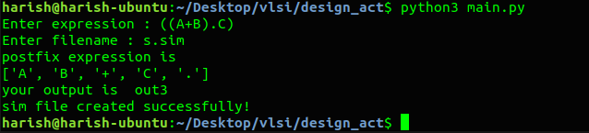

IRSIM:

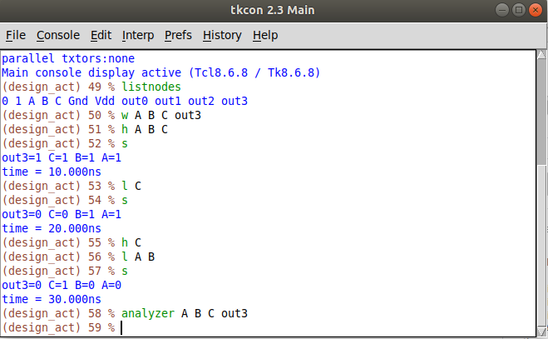
ANALYZER:
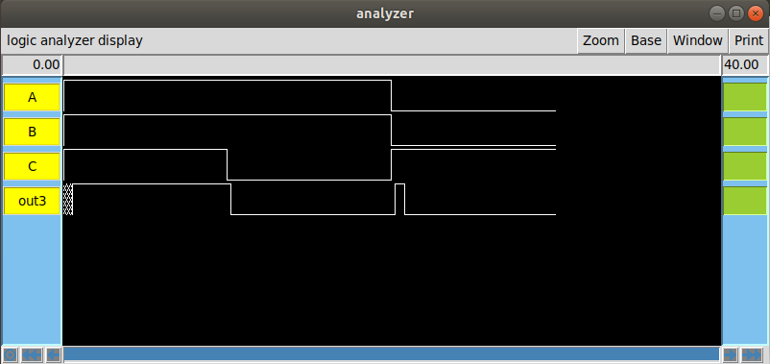

Sample 2:

Expression: (!(A+B))

Corresponding sim file is s2.sim

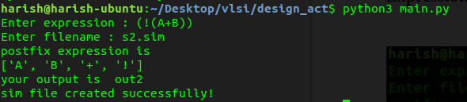

IRSIM:

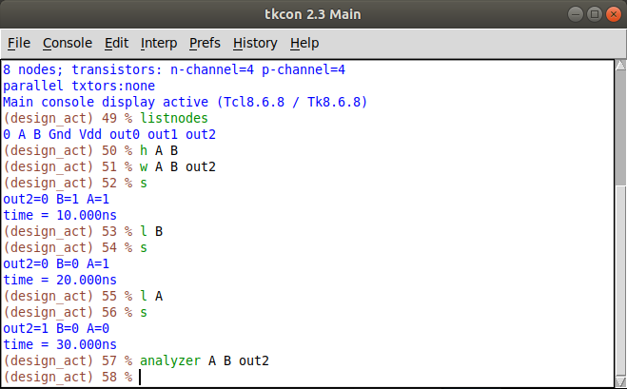
ANALYZER:

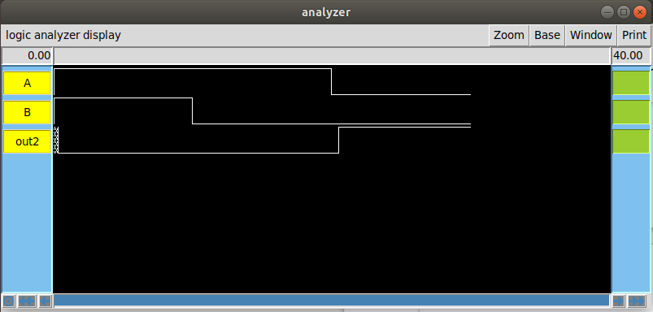

Sample 3:

Expression: ((!(A.B))+(C.D))

Corresponding sim file is s3.sim

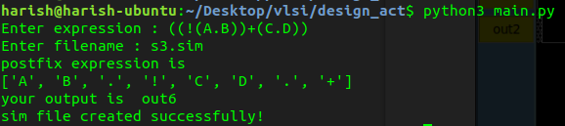
IRSIM:

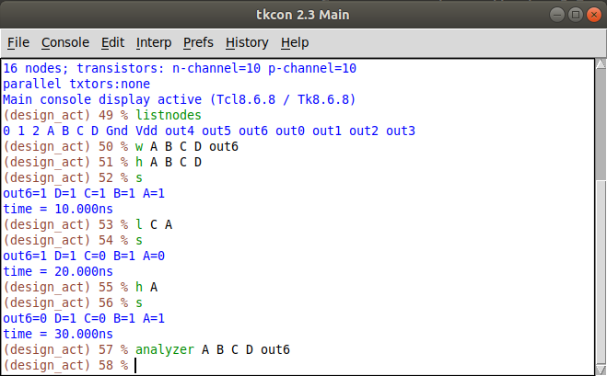
ANALYZER:

